Cloud Computing

What is Cloud Computing

The term cloud refers to a network or the internet. It is a technology that uses remote servers on the internet to store, manage, and access data online rather than local drives. The data can be anything such as files, images, documents, audio, video, and more.

There are the following operations that we can do using cloud computing:

* Developing new applications and services
* Storage, back up, and recovery of data
* Hosting blogs and websites
* Delivery of software on demand
* Analysis of data
* Streaming videos and audios

## Why Cloud Computing?

Small as well as large IT companies, follow the traditional methods to provide the IT infrastructure. That means **for any IT company, we need a Server Room that is the basic need of IT companies**.

In that server room, there should be a database server, mail server, networking, firewalls, routers, modem, switches, QPS (Query Per Second means how much queries or load will be handled by the server), configurable system, high net speed, and the maintenance engineers.

To establish such IT infrastructure, we need to spend lots of money. To overcome all these problems and to reduce the IT infrastructure cost, Cloud Computing comes into existence.

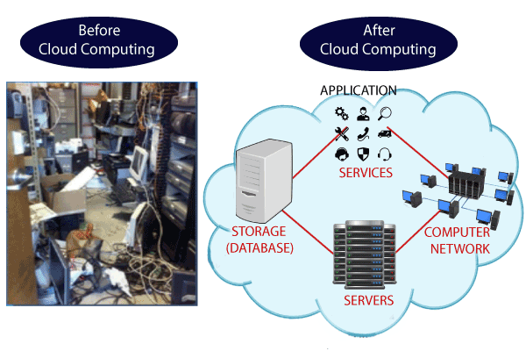

## Characteristics of Cloud Computing

The characteristics of cloud computing are given below:

**1) Agility**

The cloud **works in a distributed computing environment**. It shares resources among users and works very fast.

**2) High availability and reliability**

The availability of servers is high and more reliable because the **chances of infrastructure failure are minimum**.

**3) High Scalability**

Cloud offers **"on-demand" provisioning of resources on a large scale**, without having engineers for peak loads.

**4) Multi-Sharing**

With the help of cloud computing, **multiple users and applications can work more efficiently** with cost reductions by sharing common infrastructure.

**5) Device and Location Independence**

Cloud computing enables the users to access systems using a web browser regardless of their location or what device they use e.g., PC, mobile phone, etc. **As infrastructure is off-site** (typically provided by a third-party) **and accessed via the Internet, users can connect from anywhere**.

**6) Maintenance**

Maintenance of cloud computing applications is easier, since they **do not need to be installed on each user's computer and can be accessed from different places**. So, it reduces the cost also.

**7) Low Cost**

By using cloud computing, the cost will be reduced because to take the services of cloud computing, **IT company need not to set its own infrastructure** and pay-as-per usage of resources.

**8) Services in the pay-per-use mode**

Application Programming Interfaces**(APIs) are provided to the users so that they can access services on the cloud** by using these APIs **and pay the charges as per the usage of services**.

# **Advantages and Disadvantages of Cloud Computing**

## Advantages:

Business operations are being transformed by the transformational technology known as cloud computing. With its extensive advantages and possibilities, cloud computing has emerged as a crucial strategic tool for businesses in a range of sectors. Businesses can take advantage of various benefits that promote development, innovation, and operational effectiveness by leveraging the power of the cloud.

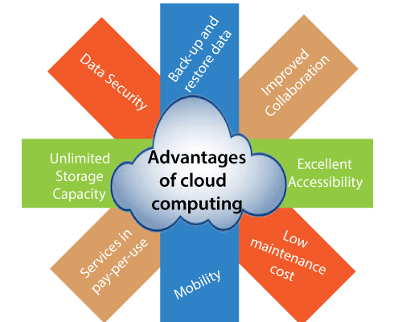

## Disadvantages of Cloud Computing

When we talk about the "disadvantages of cloud computing," we're talking about any potential drawbacks or difficulties that businesses might have when utilizing cloud computing services. These drawbacks draw attention to some restrictions or risks related to cloud computing those businesses should take into account before making a choice.

Some of the Disadvantages of Cloud Computing are as follows:

* **Vendor Reliability and Downtime:**

Because of technological difficulties, maintenance needs, or even cyberattacks, cloud service providers can face outages or downtime. Users may not be able to access their data or applications during these times, which can interfere with business operations and productivity.

* **Internet Dependency:**

A dependable and fast internet connection is essential for cloud computing. Business operations may be delayed or interrupted if there are connectivity problems or interruptions in the internet service that affect access to cloud services and data.

* **Limited Control and Customization:**

Using standardized services and platforms offered by the cloud service provider is a common part of cloud computing. As a result, organizations may have less ability to customize and control their infrastructure, applications, and security measures. It may be difficult for some organizations to modify cloud services to precisely match their needs if they have special requirements or compliance requirements.

* **Data Security and Concerns about Privacy:**

Concerns about data security and privacy arise when sensitive data is stored on the cloud. Businesses must have faith in the cloud service provider's security procedures, data encryption, access controls, and regulatory compliance. Unauthorized access to data or data breaches can have serious repercussions, including financial loss, reputational harm, and legal obligations.

* **Hidden Costs and Pricing Models:**

Although pay-as-you-go models and lower upfront costs make cloud computing more affordable, businesses should be wary of hidden charges. Data transfer fees, additional storage costs, fees for specialized support or technical assistance, and expenses related to regulatory compliance are a few examples.

* **Dependency on Service Provider:**

When an organization depends on a cloud service provider, it is dependent on that provider's dependability, financial security, and longevity. Users may have disruptions and difficulties switching to alternate options if the provider runs into financial difficulties, changes their pricing policy, or even closes down their services.

* **Data Location and Compliance:**

When data is stored in the cloud, it frequently sits in numerous data centers around the globe that may be governed by multiple legal systems and data protection laws. This may pose compliance issues, especially if some sectors of the economy or nations have stringent data sovereignty laws.

Organizations should carry out a comprehensive risk assessment, thoroughly examine the dependability and security procedures of possible cloud service providers, and build backup and disaster recovery strategies to counteract these drawbacks

# **History of Cloud Computing**

Since the beginning days of computing, when mainframe computers were accessible remotely through terminals, "cloud computing" has evolved. However, with the development of internet technologies and the demand for more effective and scalable computing solutions in the 1990s and early 2000s, the contemporary idea of cloud computing as we know it today first emerged.

